Traveller Inter-Agency Process: The Way Forward
Report of 1st Annual TIG Conference May 2015

5/19/2015
Department of Justice and Equality
WHELANMM

FOREWORD BY MINISTER OF STATE, AODHÁN Ó RÍORDÁIN, T.D.
I was very pleased to open the first Annual Conference of the Traveller Inter-Agency Process. As I said at the Conference, an event like this was long over-due given that the Traveller inter-agency process is in place since the mid-naughties and it is acknowledged by a lot of stakeholders that there have been problems with the process, in some counties more than others, not forgetting of course that there are counties in which things seem to be working very well.
The aim of the Conference was two-fold, it sought to identify the problems and find solutions while also hearing examples of good work and best practices that are underway to inform the discussion and generate innovative ideas. Presentations were made from both the statutory and the non-statutory sectors outlining their experiences and I feel that this was extremely important as it allowed us to have access to many views and opinions.
The theme of the Conference was ‘The Way Forward’ and as such delegates tried to discover what is needed to happen in the future to allow the process to deliver what it was set up for... which is to improve Traveller access to services and to provide more integrated service delivery to achieve that. I made the point at the Conference that the public service is undergoing reform, so why not the Traveller Inter-Agency process? Let us bring about reform to make the process more efficient and more responsive to customer needs.
As already mentioned, the Conference was looking for solutions, and where better to find them but from the people who are on the front-line and working at ground-level within the Inter-Agency process. I am delighted therefore to receive this Report which clearly reflects some very enthusiastic and participative debates and workshops over the course of the two days. The report provides real recommendations for the way forward, both long-term and short-term and my hope now is that the recommendations will be acted on by stakeholders as a matter of extreme urgency with the short-term intention of ensuring the Traveller Inter-Agency Groups are working as effectively as possible in full alignment with Local Community Development Committees in the development of the Local Economic and Community Plans.
As a starting point, the report will be circulated to all Local Authority County Managers and local Traveller Groups for their information and attention and it will be discussed at the next meeting of the National Traveller and Roma Inclusion Strategy Steering Group which is due to be held on 15th September. To reiterate the point made at the Conference both I and my Department will take whatever steps we can to support the implementation of change and as such I welcome the recommendations made and pledge my support to progressing them as quickly as possible.
In conclusion, I want to thank all the delegates for their engagement in the Conference and their commitment to the Traveller Inter-Agency Process, including those from the Traveller community as well as statutory and voluntary organisations.
__________________________
Aodhán Ó Ríordáin, T.D.,
Minister of State for New Communities, Culture, Equality and Drugs Strategy

Contents
Conference Delegates 6
Introduction 9
Background 10
Traveller Inter-Agency Fund (the Traveller Fund) 11
Local Government Reform / SICAP 14
Opening of the Conference 17
Contributors 21
Day 1: Thematic workshops 22
Workshop 1: Traveller Inter-Agency Process 24
Workshop 2: National TIG Strategic Framework 27
Day 2 Discussions 31
Workshop 1: Traveller Inter-Agency Process 31
Workshop 2: National TIG Strategic Framework 34
Traveller Inter-Agency Groups: The Way Forward 36
Key solutions/concrete measures to focus attention on 36
Values and Principles 38
Structures 38
Conclusions and Next Steps 40
Independent Review 40
Wide Consultation 40
Funding 41
Short-term recommendations 41

Delegates at the First Annual TIG Conference in Athlone, 18/19 May 2015. Photo: Courtesy of the Traveller Voice magazine.
Delegates at the TIG Annual Conference, Athlone – 18/19 May 2015

Conference Delegates
Aileen O'Brien | MTCMI
Áine Bird | Meath County Council
Amanda Scanlon | Roscommon County Council
Ann Mallaghan | Galway County Council
Bernadette Maughan | Sligo Traveller Support Group
Bernard Joyce | Cavan Traveller Movement
Bernard Power | member of the Traveller community
Breffni O' Rourke | LCDC
Brigid Nevin | Trav ActPrimary Healthcare
Caroline Brady | LCDC
Caroline McCleary | Donegal County Council
Catherine Joyce Collins | Blanchardstown Traveller Development Group
Catriona Hilliard | Offaly County Council
Chrissie O'Sullivan | Traveller Visibility Group
Christina Fannon | Roscommon County Council
Clare Fitzpatrick | HSE
Clare Grace
Clare Mulcahy | Limerick County Council
Colette Tuohy | Primary Healthcare Project for Travellers
Concepta de Brun | HSE
David Collins | County Galway TIG
David McCarthy | Ennis CDP
Deirdre Power | Clare County Council
Denis Moran | Roscommon County Council
Doreen Carpenter | Clondalkin Travellers Development Group
Eamonn McCann | Wicklow Travellers Group
Emma Gilchreest | Offaly Traveller Movement
Fergal Gough | Cork County Council
Frank Horne | Longford County Council
Gary Smyth | Mayo County Council
Georgina Ireland | Laois County Council
Ger Mackey | Wexford County Council
Geraldine Timlin | Sligo County Council
Hugh Friel | Donegal Travellers Project
Hugh Hogan | South Dublin County Council
Jim O'Brien | Bray Travellers CDP
JM Singh | Trav ActPrimary Healthcare
Kathleen Sweeney | Galway Traveller Movement
Kieran Butler | Westmeath County Council
Liam Hanrahan | Galway City Council
Lindsey Butler | Kilkenny County Council
Lorraine Hogan | Cork County Council
Lorraine McMahon | Ballyfermot Travellers Action Project
Maire O' Leary | HSE
Margaret Casey | Tipperary Rural Travellers Project
Margaret Nolan | Carlow County Council
Margaret O'Riada | Galway Traveller Movement
Marguerite O' Donovan | SIT Job coach
Maria Carnicer
Mark Bradley | Tallaght Traveller Community Development Project
Mary Connors | Carlow Traveller Network
Mary Hayes | Dublin City Council
Michael McDonagh | Meath Travellers Workshop
Miriam Ryan | Employ Ability Service Kerry
Niall Healy | LCDC
Nick Murphy | Fingal Travellers Organization
Nuala Stewart | Cork City Council
Owen McCarthy | Kerry Travellers Development Project
Padraig Ryan
Pat Coffey | DLRCC
Patricia Garland | HSE/Tusla
Peter Salmon | LCDC
Philomena O Connell | Clare County Council
Pippa Daniel | Travellers Support Group
PJ Dooley | Kildare Traveller Action
PJ Hanlon | SIT Job coach
Rose Leahy | SIT Job coach
Sheila Comiskey | Sit
Sinead Flynn | Leitrim County Council
Siobhan McLaughlin | Donegal Travellers Project
Storm Powell
Thomas Hayes | An Garda Síochána
Tom McDonald | Traveller development worker.
Tom Nolan | Fingal County Council
Una Daly | Roscommon Leadership Partnership
Valerie Kavanagh | Galway County Council
Vinnie O'Shea | Waterford County Council
William McDonagh | Children and Young Peoples Service Manager
Winnie McDonnell | Primary Healthcare Project

Introduction
During 2014 the Department of Justice and Equality (the Department) assessed the effectiveness of the structures in place for consultation with and delivering better outcomes to the Traveller and Roma Communities. The assessment made a number of recommendations that were accepted by the Minister of State for New Communities, Culture and Equality, Aodhán Ó Ríordáin, T.D. with the aim of improving effectiveness in the structures and furthering the Department’s strategy to promote and support the inclusion of the Traveller and Roma communities.

As part of its assessment, a series of meetings were held with Traveller Inter-Agency Groups (TIGs) from October to December 2014 aimed at identifying factors that may be inhibiting the effectiveness of the Inter-Agency Process. Given the discussions at those meetings, the Department decided to host the first annual conference for the Traveller Inter-Agency Groups aimed at identifying solutions. This Conference was held in May 2015 with the theme: “The Way Forward” and delegates were drawn from local authorities and local Traveller representatives. This report details the discussions over the two days of the Conference including any difficulties identified with the process and recommendations coming from the Conference delegates, which are provided with a view to improving the effectiveness of the Traveller Inter-Agency Process, implementing a TIG National Strategic Framework during 2015 and ensuring that the interests of the Traveller and Roma communities are reflected in the Local Economic and Community Plans being developed.

Background
In 2003, a High Level Group (HLG) on Traveller issues was established as a sub-committee of the Senior Officials Group on Social Inclusion reporting to the Cabinet Committee on Social Inclusion. Its remit was to “ensure that the relevant statutory agencies involved in providing the full range of services to Travellers, would focus on improving the integrated practical delivery of such services”.

HLG published its report in 2006 with the aim of finding ways of securing better outcomes for Travellers and improve the use of the “considerable” resources, allocated across Government Departments for Traveller-specific measures. The report emphasised the HLG’s view that inter-agency cooperation between statutory bodies is the cornerstone of enhanced service delivery, identifying it as a priority issue. It recommended that the 34 local authority areas develop a strategic plan to implement a coordinated inter-agency approach. It also recommended that the County Development Board (CDB) structure, which possesses a statutory basis and on which the most relevant agencies are represented, would be used to facilitate the development of the plans and to oversee their implementation. While the emphasis above is on statutory collaboration, the report elsewhere stresses the importance of community involvement.

The central recommendations of the HLG Report were:
- To establish a co-ordinated inter-agency strategy for the delivery of services and supports for Travellers in all cities and counties with a Traveller population. Existing structures such as the City and County Development Boards should, as far as possible, be used to develop and monitor implementation of county action plans;
- To actively promote effective consultation with Travellers at national and local level in helping to deliver the inter-agency approach, and in facilitating better communications, including conflict resolution and
- To ensure that law enforcement is included as part of the proposed integrated approach.

Monitoring of the ongoing implementation of the report is carried out by the Department of Justice and Equality, which has a co-ordinating role in relation to policy on Travellers.

Traveller Inter-Agency Fund (the Traveller Fund)
The purpose of the Traveller Fund was to give additional impetus to the work of the TIGs in developing the mechanics of better service delivery. The Department of Justice and Equality established the fund to support projects targeting the Traveller community, delivered on an inter-agency basis. The funding continued up to December 2011 and many actions from TIG strategies around the country were aided by the Fund addressing a wide range of Traveller issues, including
- Family health education;
- School transition, after school support and family support around schooling and children’s health;
- Adult development, often with a separate focus for men and women;
- Networking and building of Traveller representative capacity;
- Youth development;
- Employment and training for employment;
- Multi-cultural awareness training and community integration and
- Accommodation and tenancy support.

A major focus of the Fund was to stimulate inter-agency activity. Innovation was prioritised in the guidelines and the project assessment procedures. Innovation took place, primarily, through the establishment and operation of the new inter-agency structures as well as introducing new ways of conducting intra-group communication and embedding accountability. The collaborative process necessary to design applications and deliver projects brought greater visibility of local Traveller issues and of their inter-dependence.

The Fund was viewed to have brought considerable returns for a fairly minimal investment:
- The requirement of the Fund that applications be for priority actions linked to the county Traveller strategy stimulated those TIGs that had not engaged with the new process to formulate a strategy and commence cross-organisational communication.
- The requirement for a Traveller presence on project steering groups led to engagement with local Traveller representative groups, where this had not happened.
- Several promising projects were initiated.
- The new focus in Government strategy on developing local structures capable of progressing service delivery issues to Travellers was given greater visibility.
- Finally, through the combined application, development and reporting processes, considerable information on the process has been amassed.

Limitations of the Fund
- Inability to sustain actions long enough to make a meaningful social impact – projects which had no prospect of continuation or of mainstreaming could be counter-productive.
- 1 year timescale for projects was found to be too short to definitively establish project value. Suggested minimum project length has generally been between 3 and 7 years but, for greatest impact, should be related to the stage of Traveller life-cycle at which it is targeted, i.e. Early childhood development Family support around schooling School transition After school support Youth development Preparing for employment Employment Multi-cultural awareness training Horse project Adult training and networking....
- Failure to acquire funding led to disillusionment with the inter-agency process in some cases.
- Failure on the part of individual local organisations to have their projects prioritised for application to the Fund by a TIG can contribute to diminished participation. Compounded where outcomes are poor from a chosen project which secured funding.

Sustainability
Project reports indicated a strong connection between sustainability of projects and sustainability of general TIG activity. Collaborating around actions is the cornerstone of inter-agency work and for several TIGs funded collaborative projects have been the main binding force. In 2011, a question arose as to whether there was any point in continuing to meet, in the absence of such projects. The need for achieving successes regularly, however small, has been cited as a primary driving force of inter-agency activity by many TIG members.

National Obstacles to Mainstreaming Projects
The stimulating effect of the Traveller Fund on inter-agency work was perceived by many TIG members as being partially undermined by the absence of an adequate national strategic framework. The crux of the matter was that most agencies and Government departments, while encouraging pilot projects and expressing encouragement for inter-agency work, had not established a mainstreaming strategy for pilot projects and had not yet come to terms with the need for change in this respect.

Local Government Reform / SICAP
The Local Government Reform Act 2014 sees major realignment of the Local Government Sector under the auspices of the Department of the Environment, Community and Local Government (DECLG). DECLG delivers the ‘Social Inclusion and Community Activation Programme’ (SICAP) which aims to tackle poverty, social exclusion and long-term unemployment through local engagement and partnership between disadvantaged individuals, community organisations and public sector agencies. A key principle of the programme is to prioritise marginalised people and social groupings within the most disadvantaged communities, by targeting those furthest from access to education, training and employment and those at highest risk of social exclusion.
Travellers and Roma are a named target group of the SICAP and some actions undertaken may be traveller specific, while others may include a number of target groups including Travellers. The range of activities carried out in co-operation/collaboration with local groups, Traveller organisations, state agencies to provide supports to Travellers, typically include:
- access to further education and training
- school retention activities
- provision of tailored education and training
- primary health care and wellbeing programmes
- interagency collaboration
- after-schools and youth projects
- family supports
- community development supports
- employment/self-employment supports.
Under the LCDP, Roma are not a named target group but do benefit from LCDP activities under the 'Non-Irish nationals', although this grouping is much broader than Roma.
A stream of funding for Traveller Community Development Projects was provided via the predecessor programme to SICAP, the Local and Community Development Programme (LCDP) until early 2015. The National Traveller Partnership (NTP) under the auspices of a non-Governmental organisation, Pavee Point Traveller and Roma Centre co-ordinated the delivery of the LCDP in partnership with 14 Traveller Community Development projects by means of a community development approach, promotion of human rights and a clear recognition of Traveller ethnic identity. Through its work, the NTP seeks to tackle inequalities and promote Traveller inclusion, participation, equality and the broader cultural awareness of Traveller identity. In early 2015 that funding line transferred to the Department of Justice and Equality as part of its revised scheme. The scheme is intended to form part of a new National Strategic Framework which is being developed to support Traveller Inter-agency Groups (TIGs) in implementing local strategies based on international, national, regional and local priorities, all in consultation with Local Community Development Committees (LCDCs) in each Local Authority area.
The LCDP officially ended at the end of 2014 and was implemented on a transitional basis to the end of March 2015. Its successor programme, the SICAP, which rolled out from 1 April 2015, will form a part of each Local Authority’s Local Economic & Community Plan (LECP). Local Community Development Committees (LCDCs) will be responsible for driving the community elements of the LECP and are required to consult the Traveller Inter-Agency Groups (TIGs) in the development and implementation of the LECP.

Opening of the Conference
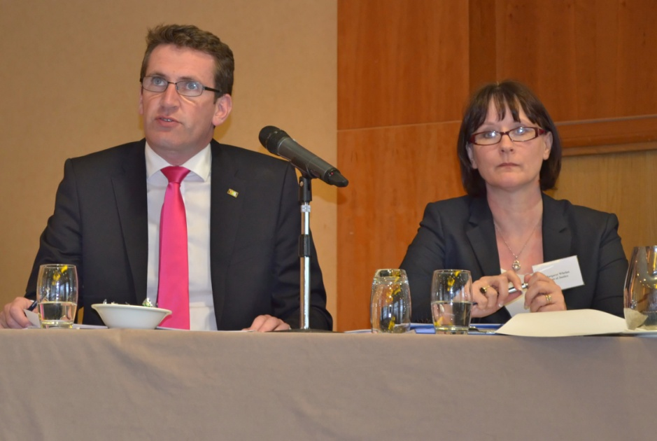
The Theme of the Conference was ‘Traveller Inter-Agency Process: The Way Forward” and it was held on 18th and 19th of May 2015 in the Radisson Blu Hotel, Athlone.
Photo: courtesy of the Traveller Voice magazine.

In his opening address, Mr Aodhán Ó Ríordáin, T.D., Minister of State for New Communities, Culture and Equality at the Department outlined that the Conference was devoted to a consultation on the future of the Traveller Inter-Agency Process to ensure that the process is more responsive to the needs and challenges of Traveller inclusion and aligned to national priorities. The event aimed to create a positive environment to allow for the generation of innovative ideas and the sharing of good practices and positive experiences and Minister Ó Ríordáin encouraged delegates to engage with the Conference on that basis. He outlined that the public service is undergoing reform and he suggested that we need to bring about reform to make the Traveller Inter-Agency process more efficient and more responsive to customer needs. “The Conference is looking for solutions and where better to find them but from the people who are on the front-line and working at ground-level within the Inter-Agency process”.

The Minister referred to the Department’s examination of the Inter-Agency Process which found some key factors that had been identified by Pobal for the success of TIGs and also some recommendations that could help to re-energise the process. The key success factors included
- involving senior personnel from key agencies,
- providing mainstreaming mechanisms for promising inter-agency actions,
- national validation of TIG work,
- training for Inter-Agency Work,
- open communication and equal participation,
- Traveller participation and representation.

The key recommendations to improve effectiveness included
- the establishment of procedures for TIGs to ensure full participation of members in decision-making,
- statutory agency involvement at both senior management and frontline level,
- the sharing of responsibility and workload between organisations,
- building Traveller representation,
- training of TIG members,
- development of County Traveller Strategies, and
- regular networking of frontline staff.

Minister Ó Ríordáin stated that both he and the Department will provide whatever support they can and outlined that already plans are afoot regarding holding regular networking events, developing platforms to share best practice and facilitate open communications and that it is the intention that this Conference will be an annual event going forward as an aid to improved effectiveness.

The Minister outlined that it is really important that the work of the Traveller Inter-Agency Groups going forward will be strategic, both informing and being informed by nationally and locally set priorities, in full consultation with all stakeholders but particularly in consultation with the LCDCs in developing the LECPs. As chair of the new National Traveller and Roma Inclusion Strategy Steering Group, he said that this is a critical issue for him and that he looked forward to learning the outcome of the Conference’s workshops and discussion on how the framework can best be implemented.

Referring to the question of a Traveller Inter-Agency fund, the Minister outlined that the Department’s assessment suggested that the stimulating effect of the Traveller Fund on Inter-Agency work was perceived by many TIG members as being partially undermined by the absence of an adequate national strategic framework or guidance from national level. To remedy this, the Department has developed a National Strategic Framework aimed at supporting the TIGs to implement local strategies based on international, national, regional and local priorities, in consultation with LCDCs. The framework was developed with a view to addressing a number, if not all, of the key success factors and recommendations mentioned above.

The Minister also referred to the revised scheme of support for Travellers which is intended to form part of the new TIG National Strategic Framework and outlined that discussions are underway with National Traveller Organisations regarding how best to achieve this. A proposal regarding a role for Regional Support Groups forms part of the discussions. However, recognising that this is not something that will be put in place overnight, the Minister announced that he had approved a proposal to inject funding to stimulate renewed TIG activity in the short-term. The funding will be made available to TIGs in the coming weeks when the Department will seek applications for projects up to a limit of €5,000 per local authority area. The Minister outlined that the call for funding applications will be informed by the discussions at the Conference and that it is likely to be the first of such calls in the near future arising from a belief that the sustainability of TIG activity is linked to the availability of funding.

Minister Ó Ríordáin concluded his opening remarks by wishing delegates well in their discussions. “I firmly believe that there is a real opportunity here to bring about change that will result in improved service provision to and outcomes for the Traveller and Roma communities. I look forward to receiving the formal report of the Conference”.

Contributors
The Department wishes to acknowledge with thanks the presentations made by the following contributors over the course of the two days:
- Ms Margaret Whelan, Assistant Principal, Traveller and Roma Inclusion Unit, Equality Division of the Department of Justice and Equality who provided some context regarding the national consultative structures and how they relate to the Inter-Agency Process.
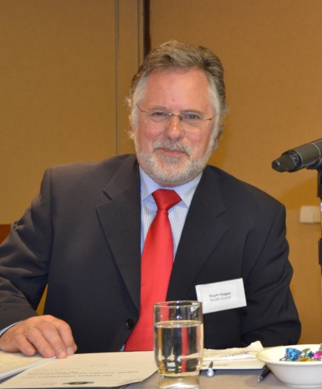
- Mr Joe Horan, former Chairperson of the National Traveller Monitoring and Advisory Committee (NTMAC) regarding his work with the Inter-Agency Process in Cork with a view to providing insights for the Conference as to how the process can move forward and to ensure that the lessons learned in one local authority area are shared with colleagues in other local authorities and that best practices identified can be replicated across local authorities.
Mr Hugh Hogan, South Dublin County Council. Photo: courtesy of Traveller Voice magazine
- Mr Hugh Hogan, South Dublin County Council regarding the experiences of South Dublin County Council which achieved past successes in the delivery of improved outcomes for the Traveller community in their jurisdiction.

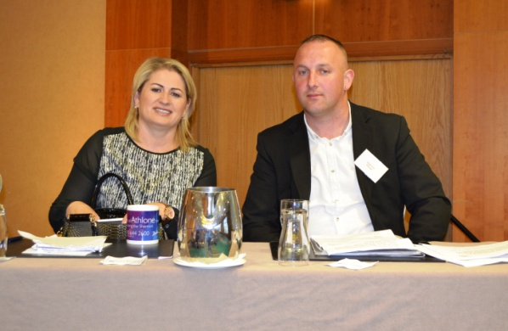
- Ms Chrissie O’Sullivan, Project Coordinator, Cork Travellers Visibility Group and Ms Siobhán McLaughlin, Project Manager, Donegal Travellers Project (supported by Mr Hugh Friel also from the Donegal Travellers Project) who spoke about the experiences of Traveller Organisations working with Traveller Inter-Agency Groups in the past and the changes needed to make the process more effective going forward.
Ms Chrissie O'Sullivan, Cork Travellers Visibility Group and Mr Hugh Friel. Donegal Travellers Project. Photo: Courtesy of Traveller Voice magazine
- Ms Marie Stanley, Higher Executive Officer, Traveller and Roma Inclusion Unit, Department of Justice and Equality who launched a new website [www.travellerinclusion.ie] and associated online discussion forum for the Traveller Inter-Agency Groups and requested delegates to provide feedback on the initiative subsequent to the Conference.
- Mr Dara Larkin, Fettercairn Youth Horse Project who provided insights into the background to the Fettercairn Project and the services on offer, including in particular the involvement of Travellers.

The presentations can be viewed on www.travellerinclusion.ie.

Day 1: Thematic workshops
Two thematic workshops relevant to the process were held in parallel on the afternoon of the first day of the Conference. The Conference delegates chose which workshop they wished to participate in and there was almost an even representation from both statutory and non-statutory sectors at each workshop.

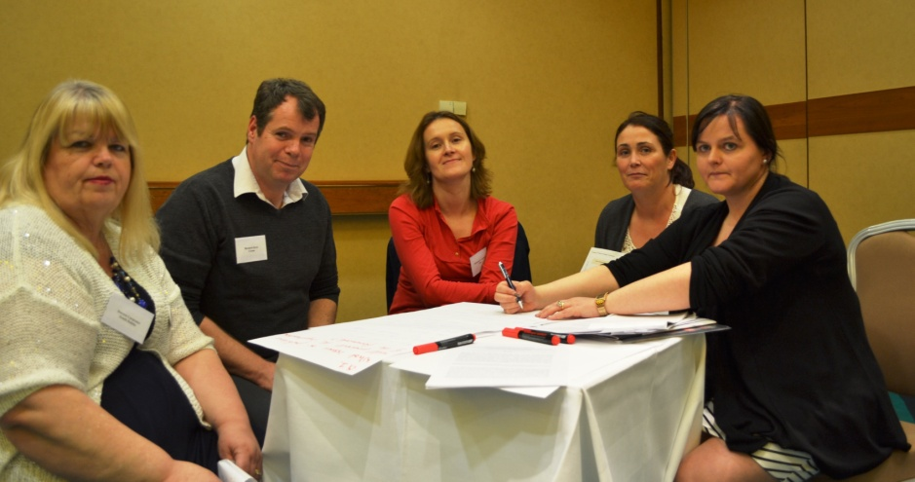
Formalise the role of the local Traveller groups to support the Traveller specific and mainstream programmes and infrastructure
Define the role of agencies and the accountability of all people/agencies sitting at the table.
Delegates participating in the workshops. Photo: Courtesy of Traveller Voice magazine

Taking a world-café approach, the aim of the workshops was to provide the possibility for participatory and interactive operational-level discussions of Traveller and Roma inclusion. Through the workshops’ volunteer rapporteurs, ideas, suggestions and questions coming out from each workshop fed-on to the debate on the next day. The workshops covered:
Positive outcomes should be shared and repeated nationally where appropriate.
I would like to see an inclusive strategy involving all stakeholders, accountability on both sides.
- Traveller Inter-Agency Process.
- Proposed National TIG Strategic Framework.

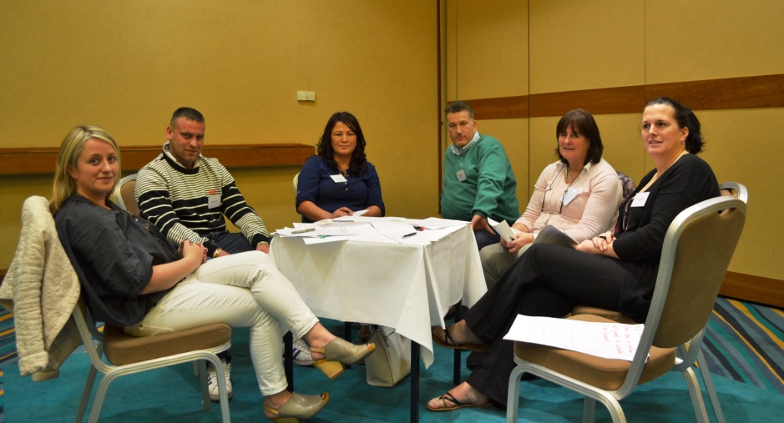
Delegates participating in the workshops. Photo: Courtesy of Traveller magazine

The outcome of each workshop is outlined in the following paragraphs. In addition, each workshop asked the delegates to respond to the following question: “What is the one thing YOU as an individual would do to improve the process?” and delegates’ responses are quoted in the margins of this section of the report.
Start from scratch – develop a totally new plan that is meaningful and has real outcomes for accommodation, health, education, mental health.

Workshop 1: Traveller Inter-Agency Process
In this workshop delegates were asked to discuss two questions and on day 2 feedback was provided by the Group’s Rapporteur, Mr Jim O’Brien, Bray Travellers CDP, as follows:

‘What issues or problems face the interagency process?’
Support Traveller Groups to represent the whole community and give them a greater role
- Leadership – How TIG should be led.
- Clear vision of TIG, involvement of Travellers needed in determining this vision. Buy in from all needed.
Need to provide sustainable, stable funding to independent Traveller-led organisations for at least a 3-5 year period at a time, linked to proven track record of delivery of programmes at local level and (b) ability to effectively mobilise/represent and engage with Travellers on an impartial basis
- Co-ordination/attendance – need decision makers at the table
All stakeholders should have a common understanding of the TIG, its role, purpose and their contribution to it.
- Need for an operational plan to include deliverables, outcomes and measures with oversight at national level
There should be a ‘bottom-up’ approach to developing strategic plans, with realistic objectives and actions. No more talking shop
- Staff continuity at agency level
- Mon performance of TIG
- Training for TIG members – anti racism/cultural awareness
- Austerity resulting in changes to or loss of services
Get Travellers involved at the highest possible levels of decision-making
- Accountability of state agencies – convening meetings, work plans
- Need engagement with local Traveller groups and Traveller community
- Identification of available Traveller funding
- Funding
- TIGs should be supporting and co-ordinating, not delivering services
- Terms of References needed for all TIG’s
- No sanctions for non-performance
- Lack of general co-ordination
- Over reliance on community health workers and Traveller champions
- Lack of recognition of Traveller groups as sounding boards
- Lack of recognition of cultural differences
- Traveller agencies carry heavier burden of TIG work
Attendance and participation of all TIG members should be prioritised
- Lack of resources for capacity building for Travellers
- Government and local level policy proofing
Fund Traveller organisations properly
- Use & abuse of power
- “Interagency” – name problematic but not to change for the sake of changing
- Departments disengaging
Positive discrimination / put a Traveller on the Department’s Team.
Clear link between TIG and LCDC
- Disconnect between DJE and D/Environment

‘What solutions or concrete measures can be put in place to address these issues or problems?’.
- Independent chair for TIGS and an interdepartmental process to agree TIG Guidelines and clear, concise, specific, Terms of Reference
Embed equality at all levels of the Framework by putting systems in place – consult IHREC
Maximum attention to funding for Traveller education and employment
- Invest in National Traveller Programme to ensure infrastructure in place countrywide
- Funding
- Regular monitoring of TIG activity
- Inter-Departmental co-ordination & agreement on Traveller Strategy
- Recognition of Ethnic Minority
- Resource a TIG co-ordinator to follow up on meetings/minutes, have oversight of the group
- Identify core groups of agencies to attend TIG meetings, TIG members should be at decision maker level
- DJE to facilitate discussion/establish TIGs in areas where not currently in existence
- Agree & monitor performance indicators for every agency involved
All stakeholders should receive cultural training so that they understand why we have the TIGs and what the issues facing Travellers, and other groups, are.
- Engagement of DSP, D/Education, Solas, ETBs & identify relevant education person/role at local level
Ensure a community development approach is actively implemented and the process is framed in planning, monitoring and evaluating with the Traveller experience respected as the starting point of the process.
- Work within Community Development Guidelines
- Sanctions for underperformance
- Review convenors of TIGs
- DJE to inform all agencies of requirement to attend TIGS
Equality proof all plans and put sanctions in place for non-delivery
- Create intermediary between relevant Government Departments (NTRISG)
- Fund community development training in leadership for young people
- Positive discrimination to increase employment opportunities
- Charter of respect
- Set up TIG networking opportunities throughout the year
- Address the disconnect between DJE and D/Environment
- Recognise that capacity building within the Traveller Community takes time
- Have a rotating chair.

Workshop 2: National TIG Strategic Framework
In this workshop delegates were asked to discuss two questions and on day 2 feedback was provided by the Group’s Rapporteur, Ms Cathy Joyce, Blanchardstown Traveller Development Group, as follows:

Issues/problems that may influence implementation of the Framework
Employ a TIG Coordinator
Build trust between agencies and Travellers
- No formal relationship between TIGs/LCDCs / Engagement protocol between LCDCs and TIGs/ Need a strong link. Is it too late given the development of the LECPs?
Make funding available to establish Traveller bodies and assist them to function properly
- TIG membership/roles need to be defined – Agencies need to buy-in to the process
TIG members to engage fully and be held accountable, annual audit by DJE
- TIG Terms of Reference should be agreed
- Clarification of the role of proposed Regional Support Groups/NTP needed
- Where are Traveller organisations in the structure? Consultation needed with all Traveller organisations. TIGs should be able to access expertise in all Traveller organisations in and out of NTP. Counties without Traveller organisations need to have capacity developed.
Traveller participation is vital and needs to be encouraged
Independent Chairperson
- Lack of operational guidelines for TIGs
- Nothing new in Framework. What’s going to change?
- Elected representation of Travellers at national level
- Redefine Strategy Headings in the Framework – need to be thematic
- Adequate resources needed – including funding for Roma if moving into that space
- TIGs should have meaningful dialogues in neutral venues
- Real accountability and implementation is missing. Consequences needed for agencies that are not performing. Suggested Charter like in Limerick Regeneration.
- Framework is top-down – bottom-up needed. Engagement between key stakeholders needs to be improved – need to link local, regional and national players, establish trust.
Establish Traveller groups in all counties
- Training for TIG members needed.
Cultural awareness/anti-racism training for all TIG members
Performance indicators for Government agencies, with monitoring and sanctions for non-participation
- Insufficient county managers’ involvement.
- Poor communication with Traveller organisations.
- Less supports outside Dublin, needs targeted investment for Traveller engagement.
- Needs linkages with other initiatives, e.g., RAPID, as well as Traveller organisations.
DJE convene key stakeholders in areas where TIG inactive with view to re-establishing TIG
Support Travellers to have their own voice, equality, inclusion and the confidence and capacity to voice this
- Framework needs to reflect link with Traveller & Roma Inclusion Unit.
- All Local Authorities must have TIGs.
- Recognition of ethnicity needs to be fast-tracked.

Proposed solutions / measures to address issues with implementation of Framework.
- Embed Traveller inclusion at all levels. Measure/track outcomes cross Departments. Ethnic identifier needed now across all Departments – data collection improvements needed. Deliver on respect/dignity.
- Redefine Terms of Reference and roles/responsibilities of the TIGs and all Traveller groups involved in the Framework. Develop a manual.
- Bringing all Traveller organisations under the Framework and confidence building for Traveller participation.
- Deal with Ethnicity on its own; remove it from the structures issue. But Ministerial announcement needed asap.
- There should be more consultation on the framework. Models for good practice in implementing the framework should be examined. Further engagement is needed to complete the framework. Perhaps a sub-Group of the Steering Group should be set up to develop and implement it. We need to define the thematic areas, e.g. health, education, employment, accommodation, etc.
Recognition of Travellers as an ethnic minority
Travellers are/have to be part of the solution and need to be given the opportunity to participate in a meaningful way.
- Adequate resources.
- Better consultation at local level, not just
Ensure buy-in by all stakeholders to ensure effective implementation of framework.
tokenistic.
- Accountability – sanctions for non-delivery, such as funding cuts to Departments. Data evaluation. DJE to advocate on behalf of Travellers to seek reinstated funding and accountability.
- Traveller proofing of all future plans with Traveller organisations, e.g. SICAP. Consult Travellers on any plan that includes Traveller specific actions.
- Training for TIGs, including induction for new TIG members.
- There should be incentives for employers to employ Travellers, and engagement with bodies such as Trade Unions, ICTU and IBEC.
- Better communication and sharing of successful projects. Develop ‘how to’ guides.
- More positive PR for Travellers, such as the Minister’s announcement. E.g. Traveller Pride initiatives.
- LECP and TIG plans should complement each other.
- Formalise LECP arrangements.
- Respect to be built into structures, to build confidence. Relationship building, equality mainstreaming.
- All agencies to remember IHREC Act and related positive duty. Equality proofing, set up system – all TIG members need training – all front-line services.
- Efforts should be taken to change public perceptions.
- Invest in Traveller education.
- Social issues: needs analysis leads to actions that work.
- Tracking and supporting young Travellers.
- In relation to Travellers in prison, efforts should be taken to support return to the community, e.g. community return programmes.
- High rate of suicide/mental health issues in Traveller community.
- Hold a Traveller organisation participatory engagement event to input into Strategy. Fund the organisations to do this. Grassroots input.
- Self determination/ethnic identifier should be built into the structures.
- Sligo LECP and TIG strategic plan linked – Equality Authority equality proofing tool used.
- Strengthening monitoring and reporting elements of the Framework to include quarterly reports to the Department.
- Build capacity in counties without TIGs – funding support needed.

Day 2 Discussions
Day 2 provided an opportunity for the Conference delegates to debate the reflections put forward by the workshops’ rapporteurs.

Workshop 1: Traveller Inter-Agency Process
The debate reflected on the way forward to a more effective inter-agency process aimed at contributing to improved outcomes for the Traveller and Roma communities in Ireland in the key priority areas of healthcare, housing, employment, education and anti-discrimination.

Comments and questions were taken from delegates including the overwhelming view from the delegates that an independent evaluation was needed of the entire process. The co-ordinating role of local authorities was questioned as well as the need for longer and shorter-term objectives for Traveller Inter-Agency Groups. The issue of non-attendance at meetings was raised and an associated need to devise a comprehensive list of relevant agencies and groups who should engage with the process, including information on the grading structures of agencies and groups and the grade level of key decision-makers. It was strongly suggested that there should be no grey area in this respect – there should be no opt-out option.

Delegates also argued for ‘non-negotiables’ to be built into the structures and put forward equality as an example, arguing that equality should be embedded in all areas of working. In addition, delegates called for ongoing monitoring of outcomes to ensure that agencies are meeting targets.

It was argued that the work of TIGs must be driven by values and principles and the positive duty provided by the Irish Human Rights and Equality Commission Act 2014 and associated responsibility given to IHREC to promote this positive duty will assist with this. Delegates argued for institutional change from top-down and for equality proofing and equality training at all levels. Additionally, training for TIGs was put forward as essential including at induction stage and beyond, and the development of a TIG charter and manual for new members was another idea.

Accountability of TIGs was an issue that was raised during the discussion and it was suggested that the TIGs should be accountable to the NTRIS Steering Group, or at a minimum the Department and that regular reporting should form part of the structures, including the issue of attendance. A template developed by Pobal could be used to further this suggestion.

The suggestion that there needs to be a two way conversation between the NTRIS Steering Group and the TIGs was put forward, e.g. the minutes of the Steering Group should be shared with TIGs and vice-versa. The new website of the Traveller and Roma Inclusion Unit, www.travellerinclusion.ie, could be a useful tool in this respect.

In terms of measurement of outcomes, it was pointed out that the LECPs are statutory and include measurement and Implementation Groups. Whether there is a role for TIGs on the Implementation Groups was queried and it was suggested that the City and County Managers’ Association (CCMA) needs to be involved in the renewal of TIGs.

The fact that some counties do not have TIGs in place was raised by delegates as a particular concern and Wexford was put forward as an example. Additionally, it was pointed out that there are no Traveller organisations in Wexford so there is a need for support to build up representation. A commitment was given by both the Department of Justice and Equality and Wexford County Council to take steps to establish a TIG in Wexford.

Concerns were raised regarding the level of cuts to Traveller organisations and its impact in Wexford, Carlow, Cavan and Monaghan and delegates asked for an assessment of the level of cuts with a view to re-investing those monies at local level.

Delegates spoke about the issue of the high turnover of staff working in the area and the need for strategic policies to deal with ensuring continuity. Sub-Groups were suggested as one solution to this and Sligo TIG which has 5 sub-Groups was referred to as an example. A further suggestion was mooted to the effect that a high level directive (perhaps DECLG) should issue to local authorities regarding prioritising the work of the TIGs and providing support for a dedicated role in local authorities to co-ordinate the work of the TIGs. A previous initiative taken by DECLG was outlined wherein that Department provided 50% of funding for a particular role which was matched by local authorities to provide a full-time employee. It was suggested by delegates that a similar approach should be taken to provide a dedicated TIG co-ordinator in each local authority. However, concerns were also expressed regarding the high number of current activities going on at local authority level and that directives may go ignored.

The question of data collection was raised by delegates suggesting that what is happening on the ground is not reported at national level. There is a need to capture data, to outline roles and responsibilities of Departments so that issues can be moved along.

The question of a lack funding for Roma communities was raised and that TIGs are only responsible for Travellers at the moment. The Department pointed out that whether the Roma community will become part of the inter-agency process will be dependent on the outcome of the assessment of need currently being conducted in partnership with Pavee Point Traveller and Roma Centre; the results of which will be available later in the year.

The final point made by delegates in this discussion related to alleged bias on the part of decision-makers which is difficult to address given that they, the decision-makers, might not even know it is there.

Workshop 2: National TIG Strategic Framework
This debate was intended to reflect on the way forward to ensuring that the Traveller Inter-Agency Groups are working strategically, informed by and contributing to the priorities at national and international level in the key areas of health, education, employment, housing and anti-discrimination.

Delegates were informed that the Framework was drafted with a view to ensuring that the TIGs were provided with a framework in which they could work on a consistent and strategic basis across counties in full alignment with national and local priorities including the development of the LECPs in consultation with LCDCs, and to address weaknesses in the inter-agency process as identified by Pobal reviews.

However, given some technical difficulties with viewing the Framework on-screen on day 2, the Department of Justice and Equality undertook to circulate the draft Framework to Conference delegates with a view to seeking observations by a given deadline and a copy of the Framework was emailed to delegates on 22nd May asking for any views or opinions to be provided on or before Friday 19th June 2015. See Appendix 1.

In response submissions were received from 8 groups from the non-statutory sector which pointed to the following additional areas as requiring particular consideration in the development and implementation of change to the inter-agency process:
- Funding for and role within the framework of Traveller organisations outside of the NTP and other locally-based Traveller groups;
- The role of and funding for the NTP organisations in the proposed new Regional Support Groups which form part of the draft framework and the proposed link to a new Traveller Inter-Agency Fund [and possibly changing the name of the fund];
- Ring-fencing NTP funding / commissioning a report to review the NTP;
- Independent funding for TIGs, additional to and separate to NTP funding / funding for Roma initiatives;
- The need for full, equal and participative consultation with Traveller organisations in developing the framework and bringing about change to the inter-agency process;
- The gender dimension;
- Protecting the independence and autonomy of Traveller organisations.

Traveller Inter-Agency Groups: The Way Forward

Key solutions/concrete measures to focus attention on
As part of the wrap-up of each of the workshop sessions, delegates were asked to identify the 3 areas in particular that they felt energy/resources should be focused on to achieve the solutions/concrete measures proposed. The three key areas identified by delegates are:

Traveller Inter-Agency Process
- Independent chair for TIGS and an interdepartmental process to agree TIG guidelines and clear, concise, specific, Terms of Reference
- Invest in National Traveller Programme to ensure infrastructure in place countrywide
- Funding

National TIG Strategic Framework
- Develop a manual which sets out Terms of Reference, roles/responsibilities of the TIGs, and brings all Traveller organisations under the Framework including confidence building for Traveller participation.
- Traveller inclusion needs to be embedded at all levels with respect/dignity built into the processes and outcomes measured/tracked across Departments including the use of an ethnic identifier – data collection improvements needed.
- The issue of Ethnicity should be dealt with on its own and removed from the structures issue.

The latter part of day 2 included a plenary discussion where delegates having reflected collectively, based on the workshops and the discussions, identified the way forward for the Traveller Inter-Agency Process. Through the sharing of views, delegates reflected on their roles and opportunities for making the process better contribute to the implementation of the National Traveller and Roma Inclusion Strategy thereby ensuring a stronger impact at national and international levels.

The following summarises the key points arising from the Conference:

Values and Principles
The delegates proposed that the Inter-Agency Process should be underpinned by the following values and principles:

- Respect, Trust, Dignity and Confidence
  - Equality and Human Rights should be embedded in all areas of working – it was suggested that the Equality Authority Proofing Tool and the positive duty imposed on pubic bodies are vehicles to progress this and that institutional change needs to come from top-down.
- Cultural competence training for all involved.
- Relationship building and good communications.
- Work within Community Development Guidelines.

Structures
Delegates espoused the need to ensure effective infrastructure is in place countrywide, involving:
  - A fully inclusive consultation process on the National TIG Strategic Framework, with a dedicated Sub-Group of the NTRIS Steering Group established to progress this, and particularly involving the City and County Managers’ Association.
  - A clear link between TIGs and the NTRIS Steering Group involving a two way conversation.
  - Discussions to establish TIGs in counties where none are currently in existence.
  - Development of a comprehensive list of agencies and groups relevant to the process.
  - Definition of the grading structure from statutory agencies who should be required to attend to make decisions and ensure no opt-out clause.
  - Engagement with all agencies regarding requirement to attend TIG meetings, and in particular, with DSP, DES, Solas, ETBs to identify relevant education person/role at local level.
  - The inclusion of all Traveller organisations in the infrastructure/framework, including those outside of the National Traveller Partnership.
  - Monitoring of outcomes, at all levels, including by local authorities.
- In relation to Traveller Inter-Agency Groups, in particular:
  - Independent chair for TIGs
  - TIG Coordinator, with additional resources if necessary
    - To follow-up from meetings/minutes
    - To provide oversight
- An interdepartmental process to
      - Agree TIG guidelines
      - Agree clear, concise and specific Terms of Reference
      - Agree and coordinate TIG Strategic Plans
      - Identify core groups/agencies as TIG members and involving meaningful decision-makers
      - Agree roles/responsibilities of TIG members and agencies/Departments/groups involved
  - Regular monitoring of TIG activity involving quarterly reports to NTRIS Steering Group based on POBAL template, including attendance at TIG meetings.
  - Training – TIG members (induction and ongoing), capacity building for Traveller organisations to engage with TIGs and agencies.
  - TIG Strategic Plans
- Clear link between LECP and TIG Plans.
- Define thematic areas for attention
- Measure/track outcomes cross Departments. Ethnic identifier across all Departments and data collection improvements needed.
- Agree and monitor key performance indicators for every agency involved, including sanctions for non-delivery.
- Include strategies to deal with changing personnel.
- Hold a Traveller organisation participatory engagement event for input.

Conclusions and Next Steps

Independent Review
The Conference concluded with a series of recommendations with the most significant being the long-term recommendation that there is an urgent need for an independent review of the Traveller Inter-Agency Process, including a review of the role of the local authority as convenor and chair of the TIGs.

Wide Consultation
In the short-term it was recommended that the Department’s current consultative process to develop the TIG National Strategic Framework needed to be expanded to involve as many Traveller organisations as possible, both in and outside of the National Traveller Partnership (NTP) and that the role of the NTP and/or Regional Support Groups in the proposed framework also needs to be revisited and given further careful consideration in consultation with all interested parties.

Funding
Furthermore, it was recommended that the issue of NTP funding, and the funding of Traveller organisations outside of the NTP, need to be given due consideration in the context of the Department’s proposals for a new Traveller inter-agency fund and a fully inclusive and participative dialogue will be necessary in this regard. It was strongly urged that such dialogue should occur as early as possible during 2015 with a view to responding to concerns on the part of Traveller organisations regarding further anticipated cuts to their funding streams.

Short-term recommendations
In the shorter-term, the recommendations arising from the Conference are:
- The Department to hold a fully inclusive, equal and participative consultation process to develop and implement the proposed TIG National Strategic Framework;
- The Department to meet agencies/groups in counties with no TIG representation (beginning with Wexford) with a view to establishing TIGs and/or Traveller representation;
- NTRIS Steering Group to give direction regarding attendance at meetings, including if possible funding support for a dedicated resource (i.e. Coordinator);
- The Department to email the Framework to Conference participants and ask for feedback.
- Subsequently, NTRIS Steering Group to establish a sub-Group to develop and implement the Framework, including consulting widely with, and considering a role in the framework for, all locally-based Traveller organisations, both in and outside of the NTP;
  - Sub-Group to call on external expertise and/or follow an approach similar to All Ireland Health Study (assessment of need);
  - The Department to hold a Traveller organisation participatory engagement event for input [perhaps linked to consultation process to revise NTRIS];
- The Department to develop a comprehensive list of agencies and groups required to participate in TIG meetings and to define the grading structure to include decision-makers;
- Monitoring mechanisms to be developed at local level following the approach taken nationally; the Department to keep TIGs informed of developments of FRA Indicators Template.
- Regarding the development of TIG Strategic Plans – the Department to circulate DECLG Engagement Protocols indicating facility to agree terms between LECPs/TIGs with a view to ensuring that all TIGs have a clear link between LECP and TIG Plans;
- Otherwise, the Department to progress:
  - Independent chair for TIGs
  - TIG Coordinator, with additional resources if necessary
    - To follow-up from meetings/minutes
    - To provide oversight
- An interdepartmental process to
      - Agree TIG guidelines
      - Agree clear, concise and specific Terms of Reference
      - Agree and coordinate TIG Strategic Plans
      - Identify core groups/agencies as TIG members and involving meaningful decision-makers
      - Agree roles/responsibilities of TIG members and agencies / Departments / groups involved
  - Regular monitoring of TIG activity involving quarterly reports to NTRIS Steering Group based on POBAL template, including attendance at TIG meetings.
  - Training – TIG members (induction and ongoing), capacity building for Traveller organisations to engage with TIGs and agencies.
  - Consistent TIG Strategic Plans.

The views and opinions expressed in this report are those of the delegates who attended the Conference to which the report relates and do not necessarily reflect the official policy or position of either the Minister of State for New Communities, Culture and Equality or the Department of Justice and Equality.
Now the Senior Officials Group on Social Policy (SOGSP)
Now the Cabinet Committee on Social Policy.
A copy can be seen at www.travellerinclusion.ie.
Pobal Traveller Inter-Agency Information Pack 2011
See Pobal reports which can be found on https://www.pobal.ie/FundingProgrammes/Pages/Past.aspx. - (a) Review of the Traveller Interagency Process March 2011, (b) Traveller Interagency Information Pack 2011 and (c) Traveller Interagency Progress Report 2008.
Announced on 3 March 2015 by Minister of State Ó Ríordáin and the Minister for Justice and Equality, Ms Frances Fitzgerald, T.D., together with the Minister for the Environment, Community and Local Government, Mr Alan Kelly, T.D., and Minister of State Ms Ann Phelan T.D.
Now amalgamated with the HLG to form the new National Traveller and Roma Strategy Steering Group chaired by the Minister of State for New Communities, Culture and Equality, Mr Aodháin Ó Ríordáín, T.D.
Please see Pobal reports which can be found on https://www.pobal.ie/FundingProgrammes/Pages/Past.aspx. These are (a) Review of the Traveller Interagency Process March 2011, (b) Traveller Interagency Information Pack 2011 and (c) Traveller Interagency Progress Report 2008. In particular, see Section 7 of the Traveller Interagency Information Pack 2011 (pages 25-28) which provides procedural tools & planning checklists for TIGs.
This has been done and feedback received by 19th June is referred to earlier in this report.
This was done by email on 27th May 2015.

